Logistics, Food, and Travel information for:

Hot Springs Yoga Retreat with Shiva
About Truth or Consequences (TorC)
For the past 50 years, Truth or Consequences has been one of the American Southwest’s best-kept secrets. A small resort town with a year round population of just over 8,000, this little town with a big name was overshadowed by its big brother, the neighboring city of Las Cruces (only an hour away.) While most towns in northern New Mexico attract tourists to their ski resorts and chic Southwestern-style vacation homes, Truth or Consequences has remained a lesser-known haven for nature lovers and those who want variety in their surroundings with a mild climate. As a result, the town has remained unspoiled and has not seen local development run rampant or real estate prices rise beyond the reach of long time locals. Here the breathtaking sandstone bluffs, nearby state parks and sunny, deep blue skies remain the biggest neighborhood attractions.
Situated on the banks of the Rio Grande in southwest New Mexico, Truth or Consequences has long been a preferred vacation site for New Mexico natives. Traditionally, they have come to bathe in the soothing hot springs or partake in the many recreational opportunities at the two large lakes nearby.

Venue:  Mothership Yoga Lounge  500 Austin St.  Truth or Consequences, NM 87901  www.mothershipyogalounge.com | 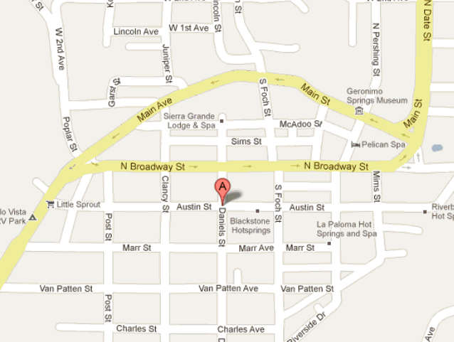

Travel
Distances
These are rough estimates, depending on how you drive. Your mileage may vary.

El Paso <2 hours
Albuquerque 2 hours
Las Cruces 1 hour
Ruidoso 3 hours
Santa Fe 3.5 hours
Silver City 2 hours

If you would like to ride share, please let us know as soon as possible and we will put you in touch with others traveling from the same place.

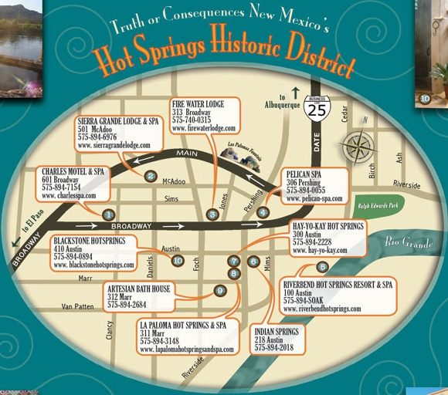

Accommodations
Most of the hotels/motels in TorC are older renovated motor court motels. They are funky, artsy, and rough around the edges. I have stayed at both Firewater and Riverbend, and held yoga classes at La Paloma and found them to be clean, yet older and kinda funky. Blackstone has a bit more polished look (I took a tour once) and Sierra Grande Lodge is the “fancy” place. Check tripadvisor.com for details and their individual website for pics. To me, it’s important to have “in-room” soaking. While all the hotels have mineral springs on premises, some are communal and some are in-room, I have indicated what I know in the first column.
Firewater Lodge  In-room springs | $10 pet fee | www.firewaterlodge.com  575-740-0314 | $70-$90
Riverbend  Communal and private for rent springs | Yes to dogs, no cats  $15/night | www.riverbendhotsprings.com  575-894-SOAK | $70-$135
Blackstone  In-room springs & private for rent | One room is pet friendly | www.blackstonehotsprings.com  575-894-0894 | $75-$135
Pelican Spa  Communal springs | ? | www.pelican-spa.com  575-894-0055 | $55-$95
La Paloma  Communal springs | Pets allowed | www.lapalomahotspringsandspa.com  575-894-3148 | $60-$140
Sierra Grande Lodge and Spa  ?not sure | ? | www.sierragrandelodge.com  894-6976 | $129-$279

Note: Riverbend has fantastic private mineral soaking for rent overlooking the Rio Grande and
Turtleback Mountain. If you’re looking for a special experience, this is worth it. You can rent their private pools by the hour, and you don’t have to be staying there to do so.

Food
(this info is taken from tripadvisor.com, * if Shiva has eaten there)
Anything in the historic district is within walking distance (<10 min)
Little Sprout has closed – for those who are returning ☹
Passion Pie Café  Coffee Shop – Bakery - Café  406 Main St., Truth or Consequences, NM  historic district  $3.75 - $7 | Happy Belly Deli*  Deli – Café  313 N Broadway St, Truth or Consequences, NM 87901-2833  575-894-3354  next door to Firewater / historic district
Café Bella Luca*  Italian  303 Jones St., Truth or Consequences, NM  575-894-9866  http://www.cafebellaluca.com/  1 block from Firewater Lodge / historic district | Los Arcos Steak & Lobster House  Mexican – Seafood - Steakhouse  1400 N Date St, Truth or Consequences, NM 87901  505 894 6200
Pacific Grill*  Italian – Asian – Seafood – Desert  800 Date Street, Truth or Consequences, NM 87901  575-894-7687  $7-$20 | Maria’s  Mexican – Best Ever? (trip advisor!)  1990 S Broadway St, Truth or Consequences, NM 87901  (575) 894-9047
White Coyote Café  Healthy – Vegetarian  113 Main Street, Truth or Consequences, NM  Historic District | Bullock’s  Grocery Store  630 North Broadway Street  Historic District

Things to Do
Elephant Butte Lake State Park – 10 minutes away  Camping, fishing, swimming, boating, stand up paddle-boarding, and other recreational activities | Soak and chill – whether you have springs in your room, or if you visit Riverbend or other communal springs, this is my absolute favorite thing to do. Soak, come out, dry off, read, stretch, soak again, and repeat. AHHH
Day trip to Las Cruces – 1 hour away  Shopping, dining, movies, etc | Get a massage –  http://www.elephantbutteinn.com  http://www.sierragrandelodge.com/  Or ask the front desk person where you’re staying, they frequently have people on-call who will come to your site for massage
Kayak the Rio Grande –  Seasonal (March – November), depending on water flow and level. Caballo state park is 16 miles south of TorC | Black Cat Books & Coffee  A nice place to hang out, have some coffee or tea, read, chat, or get a tarot reading!  128 North Broadway Street (575) 894-7070
  Spaceport America Preview Tours  Fridays, Saturdays and Sundays for the foreseeable future  9am and 1pm Friday & Saturday, 9am Sunday  Choose one of 2 pick up locations: Elephant Butte Inn or the parking lot adjacent to the Pelican Spa in downtown T or C. Tickets are $59 for adults and $29 for children under 12; Sierra County residents receive a discount. Reservations and a minimum of 2 guests per tour are required. Forms, links to the tour company, and a map showing pick up locations is on the Sierra County Tourism website. | Hiking  From my research, there does not seem to be much hiking in TorC. There is a 10.5 mile easy trail in Elephant Butte State Park. If you find any good hiking, please let us know and we’ll add it to this list.
Truth or Consequences Chamber website  http://torcchamber.com/  Sierra Country Website  http://www.sierracountynewmexico.info/ | Road Cycling  Shiva’s husband Ron likes to ride and brings his bike to ride while she teaches yoga. If you are interested in riding your bike while here, let us know and Ron may be able to give you some info about good rides.

